BOOK

**PAGE**

3825

2265

**VOLUSIA CO., FL**

**certificate: of amendment of declaration**

**OF COVENANTS, CONDITIONS AND RESTRICTIONS OF TOWNHOMES  
NORTH AT FORT ORANGE**

Ab **Secretary of the Townhomes North at Port Orange Homeowners Association, I hereby certify that the Declaration of Covenants, Conditions and Restrictions of Townhomes North at Port Orange (the "Declaration") originally executed on August 18, 1988 and filed in the Public Records of Volusia County on August 22, 1988 has been amended by an instrument signed by not less than ninety percent (90%) of the Lot Owners as required under Article IX, Section 3 of the Declaration.**

**Article IV, Section 6 of the Declaration shall now read in its entirety as follows:**

**Section 6. Uniform Rates of Assessment. Both annual and special assessment must be fixed at a uniform rate for all**

**developed Lots and may be collected on a monthly basis. A separate uniform rate applicable to undeveloped Lots, which may be lower than the uniform rate fixed for developed Lots, shall also be fixed and may be collected on a monthly basis.**

**Dated this day of**

**1993.**

**Fran Nowak, Secretary**

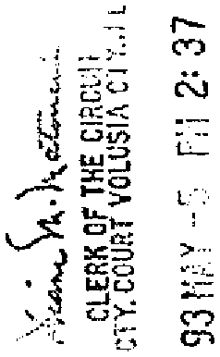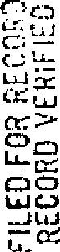

**ORI^60345**

060448

